i managed to create an unhandled exception in the Raspberry RpiRunner2, and then i solved it:

In main.xaml.cs in socket_onDataReceived :

I added Task.Delay before i send the user the message with the weight:

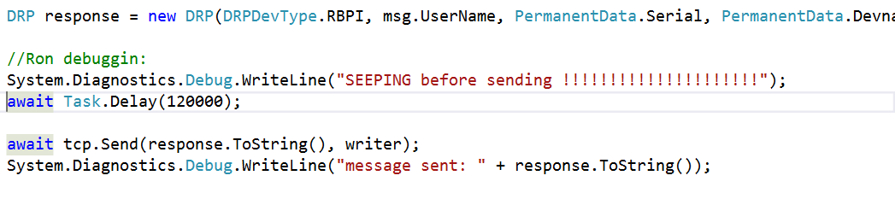

Then, after i see in the console SLEEPING before sending, i disconnect the interenet on the computer. An exception is caught – No Ip or something , but then, after like 3 minutes, an unhandled exception is thrown:

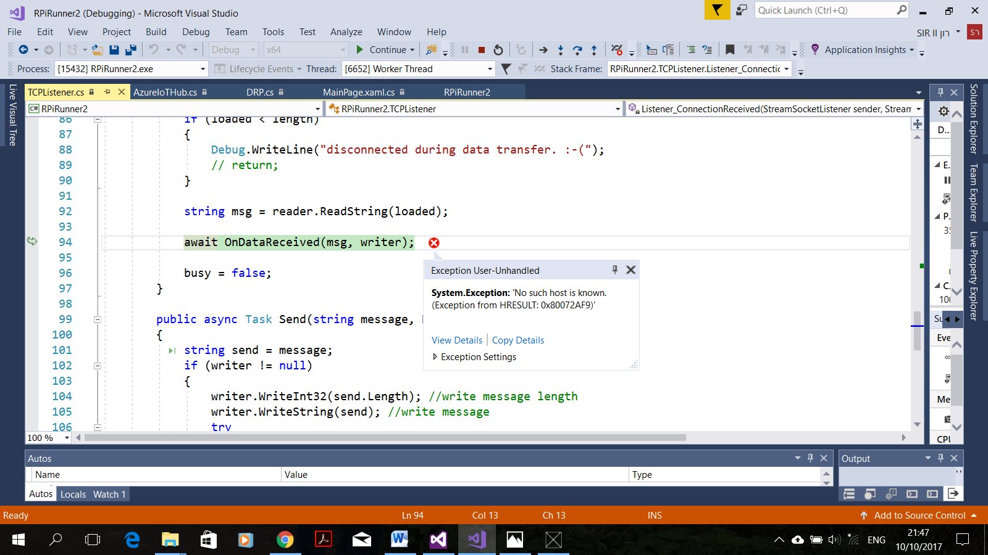

I managed to fix it by adding try- catch in TCPListener. Listener_ConnectionReceived

Then, when i did the same thing again, the exception was caught. So please add the try-catch there, and in other places where exceptions might be thrown and you don't want to pass them to another function.